PHOTOGRAPHERS
WORLD

Ammar Baig
Madiha Gul



Department of Computer Science
COMSATS UNIVERSITY ISLAMABAD
ATTOCK CAMPUS-PAKISTAN

SESSION 2017-2021

PHOTOGRAPHERS
WORLD

Undertaken By:
AMMAR BAIG
CIIT/FA17-BCS-024/ATK
MADIHA GUL
CIIT/FA17-BCS-082/ATK

Supervised By:
SIR REHAN TARIQ

A DISSERTATION SUBMITTED AS A PARTIAL FULFILLMENT OF THE REQUIREMENTS FOR THE DEGREE OF BACHELOR OF SCIENCE IN SOFTWARE ENGINEERING

Department of Computer Science
COMSATS UNIVERSITY ISLAMABAD
ATTOCK CAMPUS-PAKISTAN

SESSION 2017-2021

Title | Photographers World

Supervisor Name | Rehan Tariq Chohan  Reg No.
Members Name | Rehan Tariq Chohan  Reg No. | Email Address
Ammar Baig | CUI/FA17-BCS-024/ATK | ammarbaig41@gmail.com
Madiha Gul | CUI/FA17-BCS-082/ATK | madihag191@gmail.com


CHECKLIST:

Number of Pages in this report
I/We have enclosed the soft-copy of this document along-with the code and scripts created by myself.

My/Our supervisor has attested to the attached document
I/We confirm to state that this project is free from any type of plagiarism and misuse of the copyrighted material.

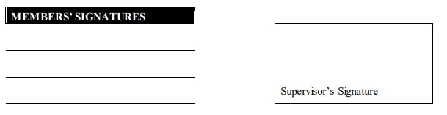

This work,entitled “PHOTOGRAPHERS WORLD has been approved for the award
of

Bachelors of Science in Computer Science

Date

External Examiner:

Head of Department:

Department of Computer Science
COMSATS UNIVERSITY ISLAMABAD
ATTOCK-PAKISTAN

UNDERTAKEN

We certify that this is my/our own work. The work has not, in whole or in part, been presented elsewhere for assessment. Where material has been used from other sources it has been properly acknowledged. If this statement is untrue, we acknowledge that we will have committed an assessment offence and shall be liable to punishable action under the plagiarism rules of HEC.

______________ ____________________
AMMAR BAIG MADIHA GUL
FA17-BCS-024 FA17-BCS-082

Acknowledgments
We are extremely grateful to ALLAH ALMIGHTY, very gracious and merciful, who enabled us to effectively finalize our project. We put all our efforts in this project. However, this would not have been possible without the loyal support of so many others. Help and assistance from many people is involved. We would like to sincerely thank all those associated with this project in any way.
We are cordially grateful to our parents, family, and friends who have supported us all the time. We are extremely grateful to them for supporting us, both financially and morally.
For his advice and encouragement, we would also like to thank Mr. Rehan Tariq. He has always been there, very useful for discussing optimization issues in this thesis work. His critical comments on our work are of the utmost importance. These comments have surely reminded us of new ideas and techniques in the fields of optimization and software simulation.

ABSTRACT
We are introducing an android based application and website in which we are providing a solution to the photographers, customers and, rentals, for the customers who face a problem during hiring photographers. Its objective is to provide ease to earn money and provide many facilities to customers, rentals, and photographers. Hiring photographers, taking equipment on rent and many more duties are done online by our application and website rather than visiting a particular place and looking for a photographer for a time-consuming event and a lot of effort toils on it.

Contents
CHAPTER 1 1
INTRODUCTION 1
1.1 Introduction 2
1.2 Problem Statement 3
1.3 Proposed Solution 3
1.4 Scope 4
1.5 Features 4
1.6 What’s new? 4
1.7 Typical previous concepts 5
1.8 project objectives and deliverables 5
1.9 Report Outline 5
CHAPTER 2 6
LITERATURE REVIEW 6
2.1 Review of Literature 7
2.2 Freelancer 7
2.3 OLX 7
2.4 eBay 8
2.5 Photographers On-Demand 9
CHAPTER 3 11
REQUIREMENT SPECIFICATION 11
3.1 Requirement Specification 12
3.2 Functional requirement 12
3.2.1 Registration for Users 12
3.2.2 Login for users 13
3.2.3 Bidding 13
3.2.4 Customer Location 13
3.2.5 Rental Location 14
3.2.6 Photographer Location 14
3.2.7 Search Bar 14
3.3 Non-Functional Requirements 15
3.3.1 Availability 15
3.3.2 Ease to use 15
3.3.3 Authentication 15
3.3.4 Efficiency 15
3.3.5 Learnability 16
3.3.6 Robustness 16
3.3.7 Security 16
CHAPTER 4 17
PROJECT DESIGN 17
4.1 Project Design 18
4.2 Methodology 18
4.2.1 First Increment: 18
4.2.2 Second Increment: 19
4.2.3 Third Increment: 19
4.2.4 Fourth Increment: 19
4.2.5 Fifth Increment: 20
4.2.6 Sixth Increment: 20
4.3 Use Case Diagram 20
4.3.1 Customer Use Case 21
4.3.2 Photographer Use Case 22
4.3.3 Rental Use Case 23
4.3.4 Admin Use Case 24
4.4 Architecture Overview 25
4.4.1 Customer Activity Diagram 25
4.4.2 Rental Activity Diagram 26
4.4.3 Admin Activity Diagram 26
4.4.4 Photographer Activity Diagram 27
4.5 Sequence Diagram 27
4.5.1 Customer Sequence Diagram 28
4.5.2 Photographer Sequence Diagram 29
4.5.3 Rental Sequence Diagram 30
4.5.3 Admin Sequence Diagram 30
4.6 Data Flow Diagram 31

Lists of Table
Table No | Table Title | Page Number
Table 2.1 | Table 2.1 Comparison of Both Application | 9
Table 3.1 | Table 3.1 FR of Users Registration | 12
Table 3.2 | Table 3.2 FR of Login Users | 13
Table 3.3 | Table 3. 3 FR of Bidding | 13
Table 3.4 | Table 3. 4 FR of Customer Location | 13
Table 3.5 | Table 3. 5 FR of Rental Location | 14
Table 3.6 | Table 3. 6 FR of Photographer Location | 14
Table 3.7 | Table 3. 7 FR of Search Bar | 14
Table 3.8 | Table 3. 8 NFR of Availability | 15
Table 3.9 | Table 3. 9 NFR of Ease To use | 15
Table 3.10 | Table 3. 10 NFR of Authentication | 15
Table 3.11 | Table 3.11 NFR of Efficiency | 16
Table 3.12 | Table 3. 12 NFR of Learnability | 16
Table 3.13 | Table 3. 13 NFR of Robustness | 16
Table 3.14 | Table 3. 14 NFR of Security | 16

List of Figure
Figure 2.1 | Figure 2.1 Freelancer Interface | 7
Figure 2.1 | Figure 2.2 OLX Interface | 8
Figure 2.1 | Figure 2.1 eBay Reviews | 9
Figure 4.1 | Figure 4.1 Incremental SDLC Model | 18
Figure 4.2 | Figure 4.2 Customer Use Case Diagram | 21
Figure 4.3 | Figure 4.3 Photographer Use Case Diagram | 22
Figure 4.4 | Figure 4.4 Rental Use Case Diagram | 23
Figure 4.5 | Figure 4.5 Admin Use Case Diagram | 24
Figure 4.6 | Figure 4.6 Customer Activity Diagram | 25
Figure 4.7 | Figure 4.7 Rental Activity Diagram | 26
Figure 4.8 | Figure 4.8 Admin Activity Diagram | 26
Figure 4.9 | Figure 4.9 Photographer Activity Diagram | 27
Figure 4.10 | Figure 4.10 Customer Sequence Diagram | 28
Figure 4.11 | Figure 4.11 Photographer Sequence Diagram | 29
Figure 4.12 | Figure 4.12 Rental Sequence Diagram | 30
Figure 4.13 | Figure 4.13 Admin Sequence Diagram | 30
Figure 4.14 | Figure 4.14 Data Flow Diagram | 31

CHAPTER 1

INTRODUCTION

1.1 Introduction

Our Application is based on android development that is getting popular nowadays all around the world. Android is an easy platform for everyone to do their jobs online rather than the conventional way to fulfill their needs. Online jobs provide multiple services to a customer like hiring an employee, assigning jobs, sharing expertise, and so on. For example Freelancer and fiver application. It can allow a person to hire employees for a job according to their demands. Customers can easily fulfill their requirements with more convenience. An effective process to deal with photographers, customers and rentals is the key point of our application.

This is the most well-to-do job because the customer does not need to meet with photographers personally at their studio for hiring a photographer for an event, no need to go to find equipment. No need for traveling and getting tired, just find a list of photographers, customers, and rentals by using "Photographers World". This is the easiest way to hire a photographer based on its ratings.

Its objective is to provide ease to earn money and provide many facilities to customers, rentals, and photographers. Customer, rentals, and photographer made their profile and provide their special information. Photographer also tells in a description about his category of work like nature, wedding photography or wild photography, etc. The first photographer made his/her complete profile and provide information like the working hours, skills, charges, and category of photography and also shares pictures of his/her work in the portfolio. Then the customer made his complete profile and after that, he/she is provided with a list of photographers that are near to his/her location. Also, they are recommended with the list of photographers with the latest trend in a city with category and also through the rating system. Rating will be based on many features like photographer’s work quality, timing to reach to event’s location, quality of photos, cost-effective or not. Customer can communicate with the photographers and rentals by the call or SMS and WhatsApp using sim but our app directly suggest these features and also they will get notification about the messages. Customers can directly hire the photographer or can generate his/her request and many photographers Bid on the request. Based on price and work, customers hire photographers according to need. Rentals also made their profile and provide different equipment to be given on rent. The same person in this app can be a photographer, customer, and rental.
Every entity using our application or website will be able to update his/her profile. As the photographer, Customer, and Rental presented their profile by entering legal information and their expertise of work. User can be login as a guest by Gmail, Facebook, etc.
The main goal of this project is to interject some new features like the bidding corner, location service, and many more for customers, photographers, and rentals. That is somehow usually experienced in websites (freelancers) to assigning projects etc.

1.2 Problem Statement

There is very difficult to find the best photographer for your event in your town and also the equipment for rent. Customers want photo-shoot of their events and hire photographers without knowing the level of his/her photography and in the end, they are not satisfied with the work of the photographer and waste their time and money. Some photographers have very impressive photography skills but due to lack of money, they can’t afford a Photo studio for themselves. There is very difficult to find a photographer outside your hometown. You go on a trip or some journey and at that location, you want some photographer for your photo-shoot but due to lack of knowledge of that location, you can’t find a photographer at that time. Some people have the best equipment which they rarely use for themselves so they want to earn some money by giving that equipment on rent but they could not find customers. So many people had equipment lying around.

1.3 Proposed Solution

This project aims to provide an online application and website to eliminate all the difficulties mentioned above. Through our application and website, Customers will easily hire photographers for their events and they can easily get different equipment on rent. Photographers will also get work easily through the orders placed by the customer as well as just by looking at the user’s request and bid on that request and fix the charges of the event. The time of photographers will not waste and they will get their desired work according to their needs and they will easily find their way to earn money.

1.4 Scope

The scope of this project is
- Photographer, Customer and Rental Location
- Developed in the Android Platform
- User-Friendly Interface
- Customer control panel
- Photographer Control panel
- Rental Control Panel
- Photographers Ratings
- Hiring photographers by Customer
- History
- Error maintenance
- Activity log

1.5 Features

These are the following features
- Renting
- Hiring
- Bidding
- Rating

1.6 What’s new?

Our idea is quite different in this way that we have combined the concept of the simple idea of taking equipment on rent, hiring a photographer with the bidding. Our idea is a combined idea of freelancers and “Olx” websites. This application makes its unique identity by having the feature of bidding and hiring photographers based on their ratings etc. with complete detailed information. The same person in this app can be a photographer, customer, and rental. These are an attractive feature in this application.

1.7 Typical previous concepts

So many applications can be found on the Google play store. Previously build application named Photographers On-Demand, but you can register as a photographer or customer but not from the same account, Customer cannot create his/her request, no verification on signup and no Rentals.

1.8 project objectives and deliverables

- To save effort, money, and time.
- To facilitate user through the work of photographers which is based on ratings without visiting the photographer’s studio.
- To provide instant online help
- To facilitate the photographers to participate in bidding publicly.
- To search relevant data according to the need.
- To use rating algorithms etc.
- To serve humanity.

1.9 Report Outline

The content of the report explains the phases that we are required to complete this project.
This report documents the overall process including.
- Literature Review
- Requirement Specification
- Project Design
The report also contains relevant figures and tables

CHAPTER 2

LITERATURE REVIEW

2.1 Review of Literature

In this Section, Some past work will be explained which relates to our current project will be presented to get an idea where our project will stand concerning the previous work with their features

2.2 Freelancer

Freelancer is the most popular web-based application and their work is closely related to our application. On this website, the Programmer made their profile and can work as an employee and can post a project. This website is closely related to our application. In Freelancer Developers or software, the house posts their project to hire a programmer for their work. Our app will have a section where customer can post their project and the photographer bid on it and achieve it.

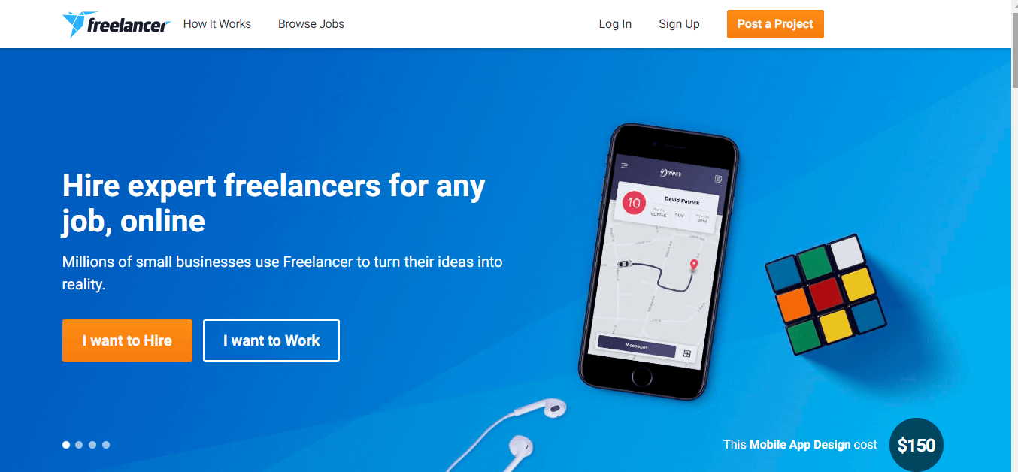
Figure 2.1 Freelancer Interface

2.3 OLX

Olx is the most popular web-based application and their work is closely related to our application. It is a parallel system. Of the customer side by side Customers can buy and sell their products. These Activities are performed by uploading their products just like the advertisement. A customer sees the products and buys them which he wants from a website. Seller Make their account on this website and upload their equipment or goods etc., along with the price, description, and Name of the product and expected from the website to sell them to other users.
The Buyers can search the products and see the contacts of the seller and location. They can negotiate with the seller to sell items. In this application, the seller can sell the use of things Quality of electronic equipment and material.

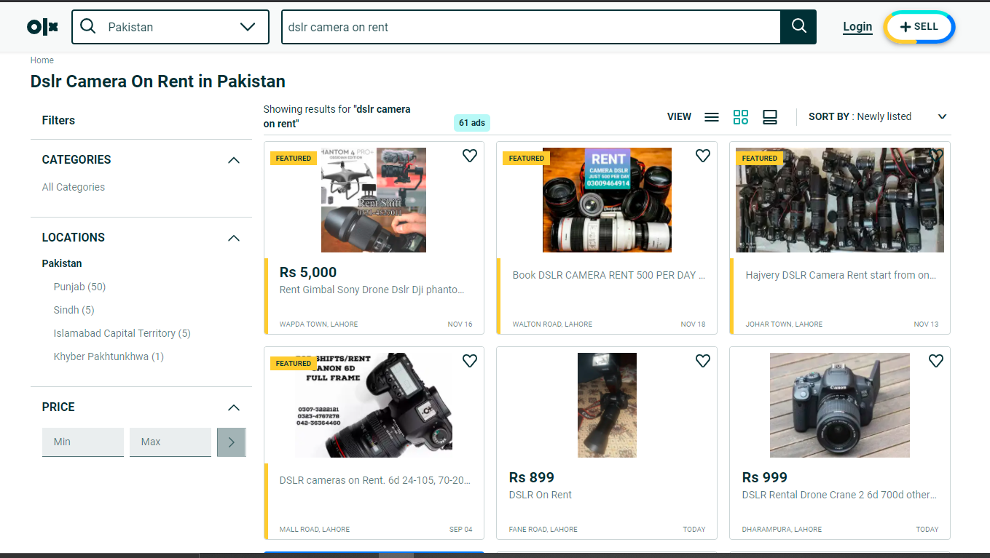

Figure 2.2 OLX Interface

2.4 eBay

eBay was officially founded in 1998. It is an e-commerce platform that allows users to buy and sell items easily and efficiently. The company assures the security and Guarantee to the customer are getting the best price available on the most items which are available on the eBay website The eBay website gets an average of about 817.6 million visits per month. eBay has 100M+ Downloads on the Google Play store. Its means there are millions of active user who use an application to buy and seller items. The seller can receive an additional discount on their final value of the fee for eBay plus orders. Buyers can share and rate their experience with sellers. Buyers can make unlimited, unconditional free returns of items they purchase with eBay Plus.

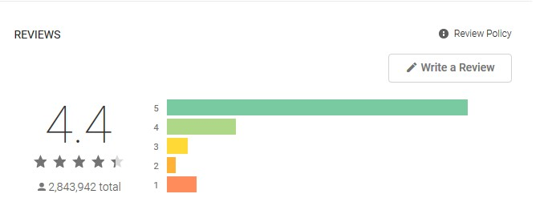

Figure 2.3 eBay Reviews

2.5 Photographers On-Demand

One application “Photographers On-Demand” place on the play store and its purpose is only to search for photographers and hire him/her and that application has many errors. Our app is a unique digital platform that enables direct communication between customers and photographers as well as rental and customer/photographer.
Table 2.1 Comparison of Both Application
Photographers On-Demand | Our Application(Photographers World)
You can register as a photographer or customer but not from the same account | You can register as a photographer or customer or rental from the same account
Only customer hire photographer | Customer can hire a photographer as well as photographer can hire photographers
Customer cannot create his/her request | Customer can create his/her request and many photographer Bid on it
Not verification on signup | Verification of user on signup using OTP
Customer Location will not show | Customer/photographer Location will be shown
No Rentals | Customer can get different equipment on rent
 | Workplace location will be show
 | Everyone can see each other profile except admin
 | Can be login with own made account, Gmail, etc.

CHAPTER 3

REQUIREMENT SPECIFICATION

3.1 Requirement Specification

This chapter explains the functional and non-functional requirements of the software which we are developing. The functional requirement will explain what the system is expected to do. The functional requirement explains the behavior of our system and it’s component-based on a particular input. It will explain diagrammatically the incoming chapter by using the use case diagrams. This requirement will tell what our system is supposed to do. These requirements are tested in the testing phase and the result will be obtained which will be used in the assessment. These explain the behavior of our system while the non-functional requirement is the constraints. The non-functional requirement will be fulfilled to make our system is more efficient and effective. It defines the attribute of the system. At the end of this chapter, the hardware and software implementation will be explained. Before going to functional and non-functional requirements we see some terminologies which are given below. Let us discuss some technologies which are uses regularly.

3.2 Functional requirement

This section will provide information about the functional requirements of the project.

3.2.1 Registration for Users

Table 3.1 FR of Users Registration
Name | FR-1: Registration
Summary | User must register him/herself with a pic to see the functionalities of  “Photographers World”.
Requirements | User will be entered in-app and website by giving the First Name, Last Name, age, Username, password and phone number, location with the type (photographer, Customer, Rental).  User can register as a photographer or customer or rental from the same account.

3.2.2 Login for users
Table 3.2 FR of Login Users

Name | FR-2: Login
Summary | User Must be Login On “Photographers World” application and website to hire photographers, post an event request, and buying or renting the equipment.
Requirements | Users will be entered into the Application and website by giving the correct email and password. Users can log in as photographers, customers, and Rental.

3.2.3 Bidding
Table 3. 3 FR of Bidding

Name | FR-3: Bidding
Summary | Customers can generate a request to hire a photographer for an event and many photographers Bid on the request.
Requirements | Customer will generate a post about hiring a photographer.  The photographer will bid on those Customer posts and will achieve the project. Customers will select a photographer based on their good suggestions so the project would be assigned to that photographer.

3.2.4 Customer Location

Table 3. 4 FR of Customer Location

Name | FR-4: Customer Location
Summary | Customers can mention the exact location of their town.
Requirements | Customer will provide their location.

3.2.5 Rental Location

Table 3. 5 FR of Rental Location

Name | FR-5: Rental Location
Summary | Rental can mention the exact location where they will give equipment on rent or a specific price.
Requirements | Rental will provide their location.

3.2.6 Photographer Location

Table 3. 6 FR of Photographer Location

Name | FR-6: Photographer Location
Summary | Photographer can mention the exact location
Requirements | Photographers will provide their location so that customers will easily hire a photographer for an event according to their location.

3.2.7 Search Bar
Table 3. 7 FR of Search Bar

Name | FR-7: Search Bar
Summary | Customers must search for the photographer and different types of equipment.
Requirements | Customers will search for the person and product.

3.3 Non-Functional Requirements

Following are the non-functional requirements of our Project.

3.3.1 Availability

Table 3.8 NFR of Availability

Name | NFR-8: Availability
Summary | Our application and website will be available 24/7 so that the users can use it easily at anywhere anytime.

3.3.2 Ease to use

Table 3.9 NFR of Ease to use

Name | NFR-9: Ease to use
Summary | Our application and website are very easy to use. It has a user-friendly interface that allows the user to get the appropriate response. It has no ambiguity so that the user cannot distract from the right purpose.

3.3.3 Authentication

Table 3.10 NFR of Authentication

Name | NFR-10: Authentication
Summary | Authentication is important every time a user login; if a user is new then the user must be sign-up first and then the user can be login by valid Email and Password.

3.3.4 Efficiency

Table 3.11 NFR of Efficiency

Name | NFR-11: Efficiency
Summary | Our Application and website will provide accurate responses to the user. It takes less time to respond.

3.3.5 Learnability

Table 3.12 NFR of Learnability

Name | NFR-12: Learnability
Summary | Our Application or website is very easy to learn. Interfaces allow users to quickly become familiar with them and able to make good use of all their features. Our application or website has a very learnable interface the user can immediately grasp how to interact with the system.

3.3.6 Robustness

Table 3.13 NFR of Robustness

Name | NFR-13:Robustness
Summary | Our Application and website can cope with errors during exception and cope with erroneous input. The application and website are developed to handle all the exceptions and errors.

3.3.7 Security
Table 3.14 NFR of Security

Name | NFR-14:Security
Summary | All user’s data will be Store in Goole Product Named as Firebase. The only Developer can access that data. The second person cannot access the details of the ‘Photographers world’ application and website other than the owner.

CHAPTER 4

PROJECT DESIGN

4.1 Project Design

This chapter discusses the design of the project.

4.2 Methodology

In the incremental SDLC (System Development Life Cycle) model, the project is divided into a smaller number of increments and each increment has a phase with time-lapse. The first increment is often a core product with many supplementary features in this method.

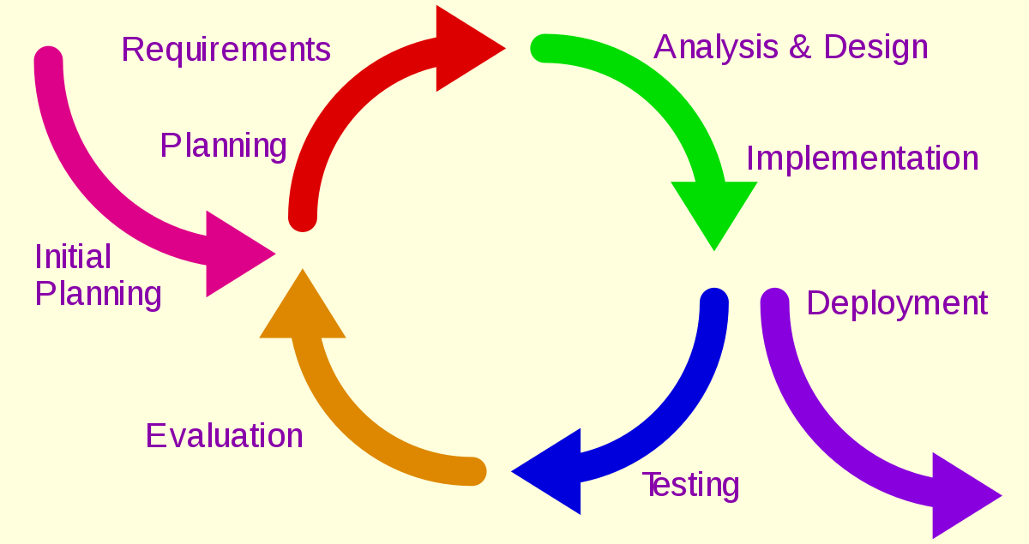

Figure 4.1 Incremental SDLC Model

The development process model which we are using in our project is the incremental model. In this, we broke project requirements into increments for the software development cycle. We have selected this model to make projects in increments and then show the supervisor if any change is required so that can be done easily and efficiently.

4.2.1 First Increment:

    - Login as photographer, Customer and Rental
    - Register as Customer, Photographer and Rental
    - Front end design of all page (prototype)

4.2.2 Second Increment:

- Customer Module
- Searching Photographer
- Uploading pic
- Updating own details
- View photographer
- View Rental
- Hire photographer
- Create Post for Bidding
- Get equipment on Rent

4.2.3 Third Increment:

- Photographer Module
- Searching Customer Requests
- Add Posts (work)
- Uploading pic
- Updating own details
- View Customer
- Bidding on Customer Request
- Provide own information(Working hours, Skills, category of photography etc)
- View Rental
- Get Equipment on Rent

4.2.4 Fourth Increment:

- Rental Module
- Uploading pic
- Updating own details
- Add equipment
- Equipment Information(price, brand etc)

4.2.5 Fifth Increment:

- Admin Module
- View photographers
- View Rentals
- View Customers
- Manage Accounts

4.2.6 Sixth Increment:

- App Integrating Module
- Integration with Google
- Integration with Authentication
- Integration with Google Maps

4.3 Use Case Diagram

The use case diagram is a way to summarize the details of the system and the users in the system. It is usually displayed as a graphical description of the interaction between different elements in the system. Actors are the primary persons who operate on the system. The actor must be associated with at least one use case.

4.3.1 Customer Use Case

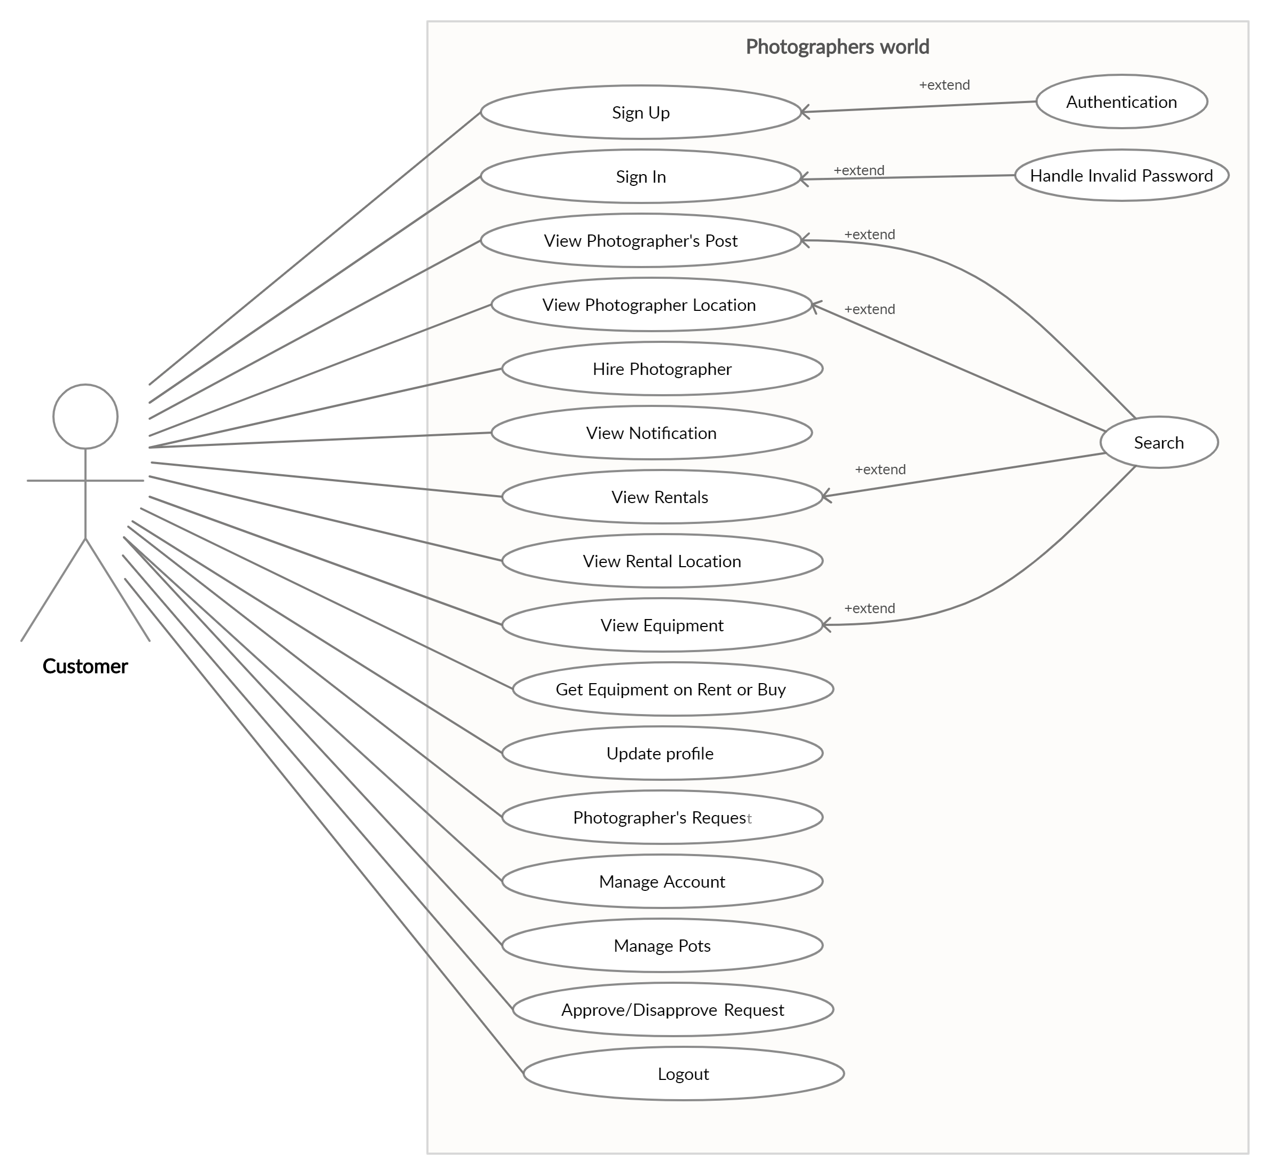
Figure 4.2 Customer Use-Case Diagram

Figure 4.2 shows the customer behavior of the system. In this system, the user can be a customer, photographer, and Rental with the same Account. The customer will enter in the application and website but before he will register himself/herself. Two options Sign In and Signup will show in front of the page. If the customer needs signup so he will choose signup and then login. After Login he will be seen and perform the functionalities of the system. He can update his profile. He can see the photographer, Rental, different types of equipment, and also see a notification He can search the different photographers, rentals, and different types of equipment. Customers will see the location of photographers and determine which is nearest. And through the recommender system will show the nearest photographer to the customer.

4.3.2 Photographer Use Case

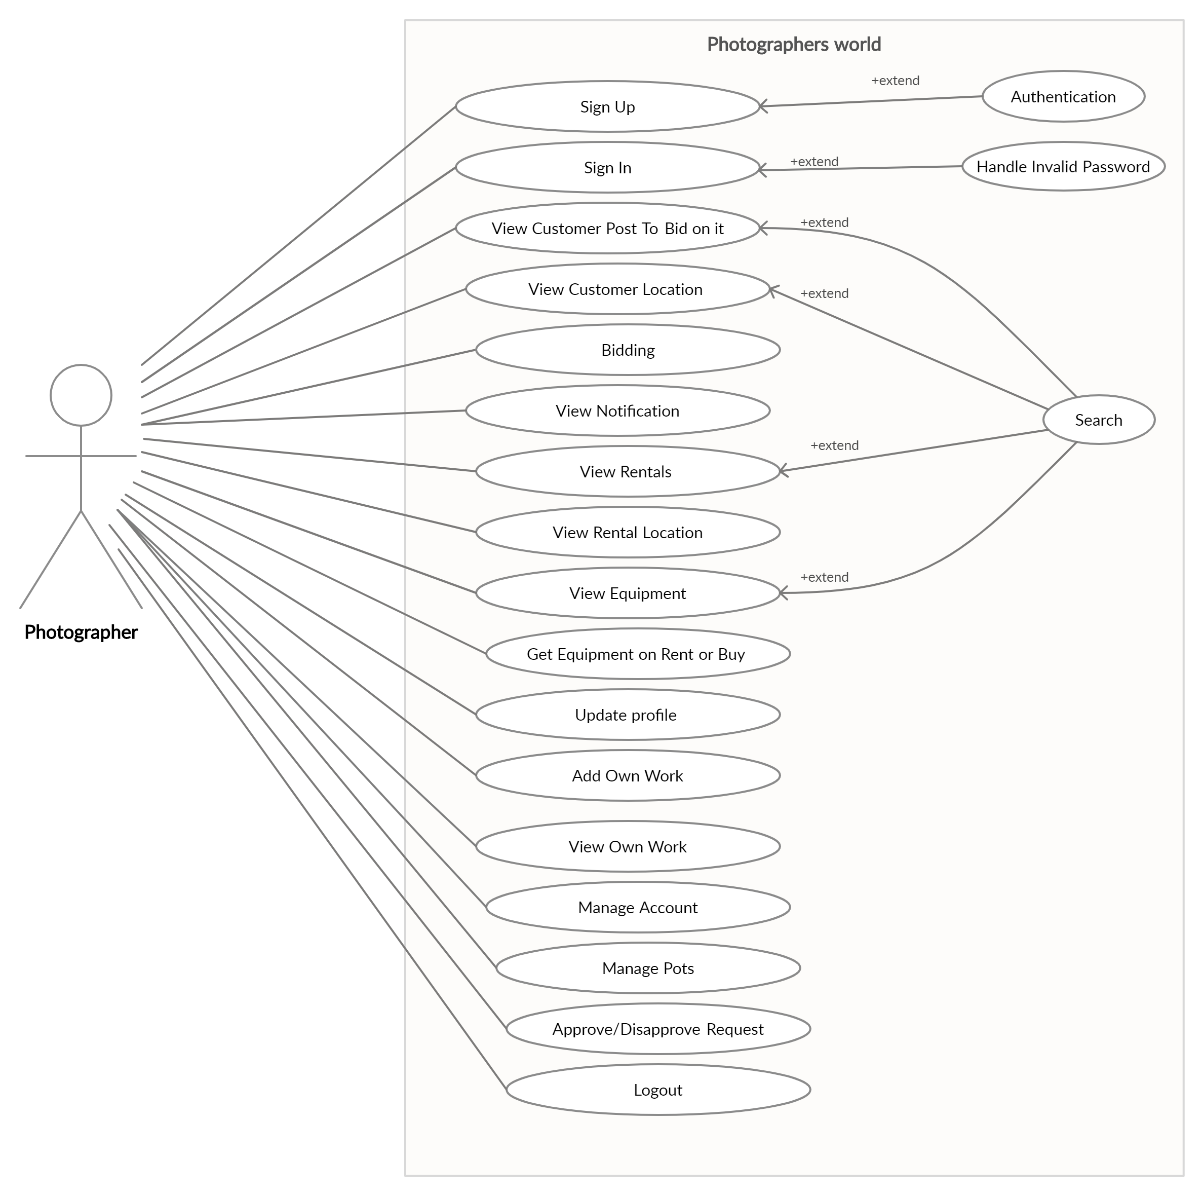
Figure 4.3 Photographer Use-case Diagram

Figure 4.3 shows the photographer’s behavior in the system. The photographer will enter in the application and website through the signup or Sign In. Sign In and Sign Up options available on the front of the page. If the photographer needs signup so he will choose signup and then login. After Sign In he will perform the functionalities of the system. He can update his profile. He will see customer posts where he can bid on it and also see the location of the customer. Photographer will see the rentals and get equipment on rent. And also see the location of the rentals and photographers. Photographer will update his profile and manage the account. He will manage their posts and participate in bidding. He will add his work and also see their work. And he will search for different posts where he can bid on it.

4.3.3 Rental Use Case

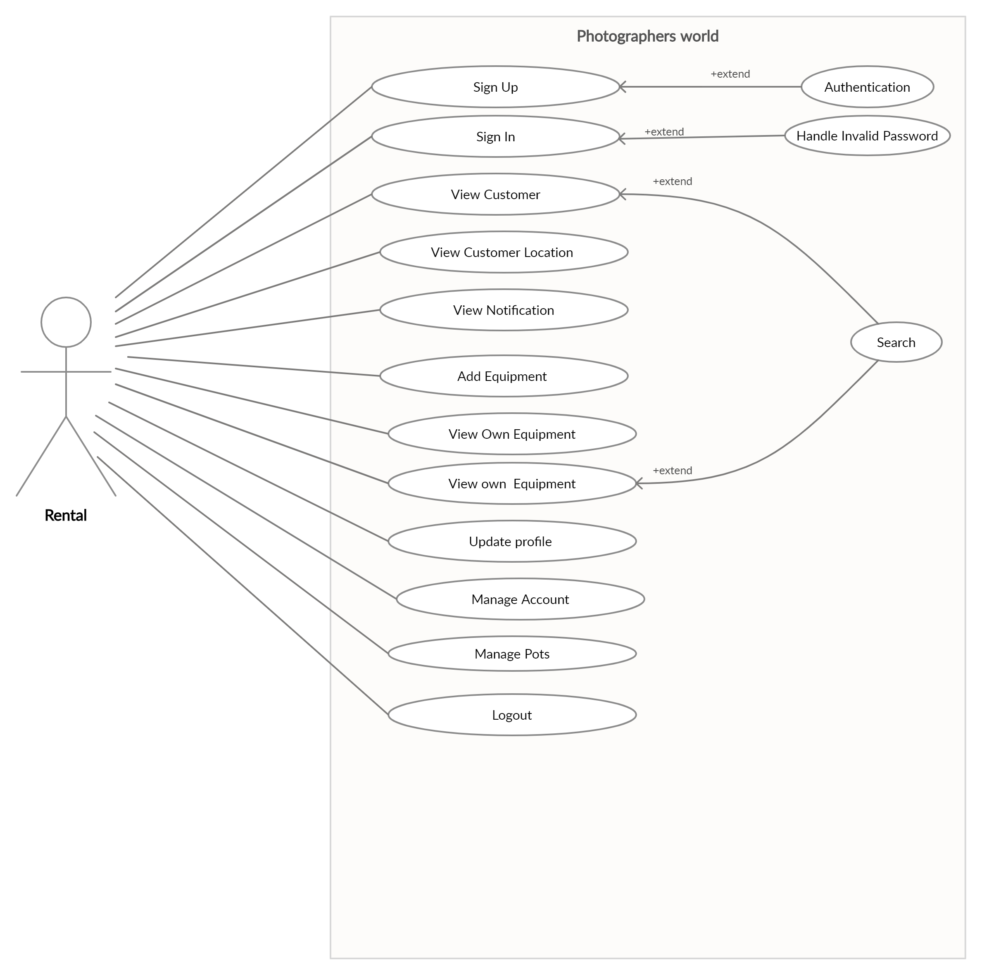
Figure 4.4 Rental Use-Case Diagram
Figure 4.4 shows the Rental’s behavior in the system. The rental will enter in the application and website through the signup or Sign In. Sign In and Sign Up options available on the front of the page. If the Rental needs signup so he will choose signup and then login. After Sign In he will perform the functionalities of the system. He can update his profile. He will add their equipment and also see them. And rental manages their posts. Rental can see Notifications and also delete them.

4.3.4 Admin Use Case

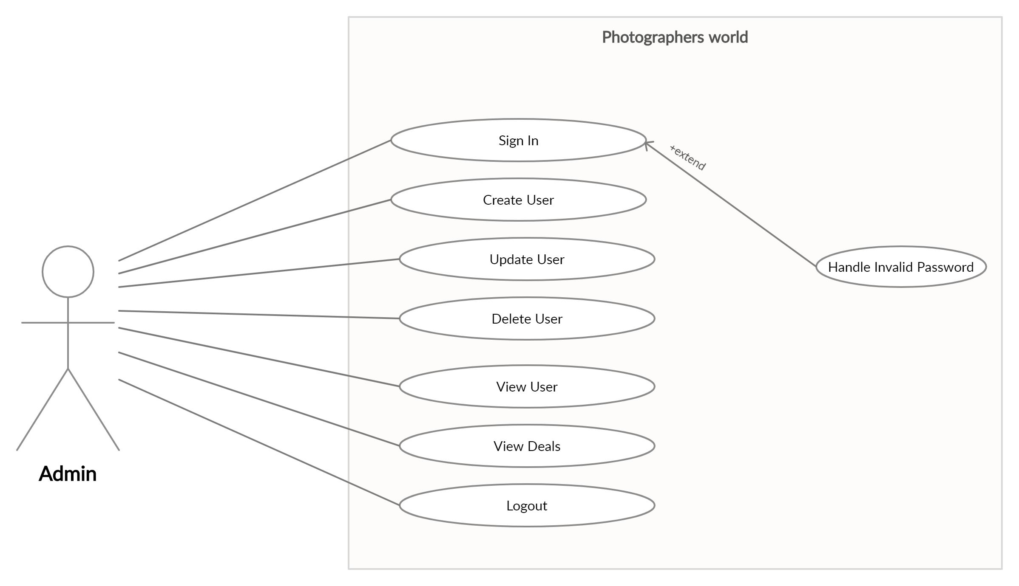

Figure 4.5 Admin Use-Case Diagram
Figure 4.5 shows the behavior of the Admin in the system. The Admin will enter in the website and application through the sign in. Admin can create user, update user, delete user, and also view user. Admin will access to see all deals between photographers, Rentals, and Customers.

4.4 Architecture Overview

In this section, there is a diagram that will describe the architecture of our system which we are developing. The diagram will show how the system’s components interact with each other.

4.4.1 Customer Activity Diagram

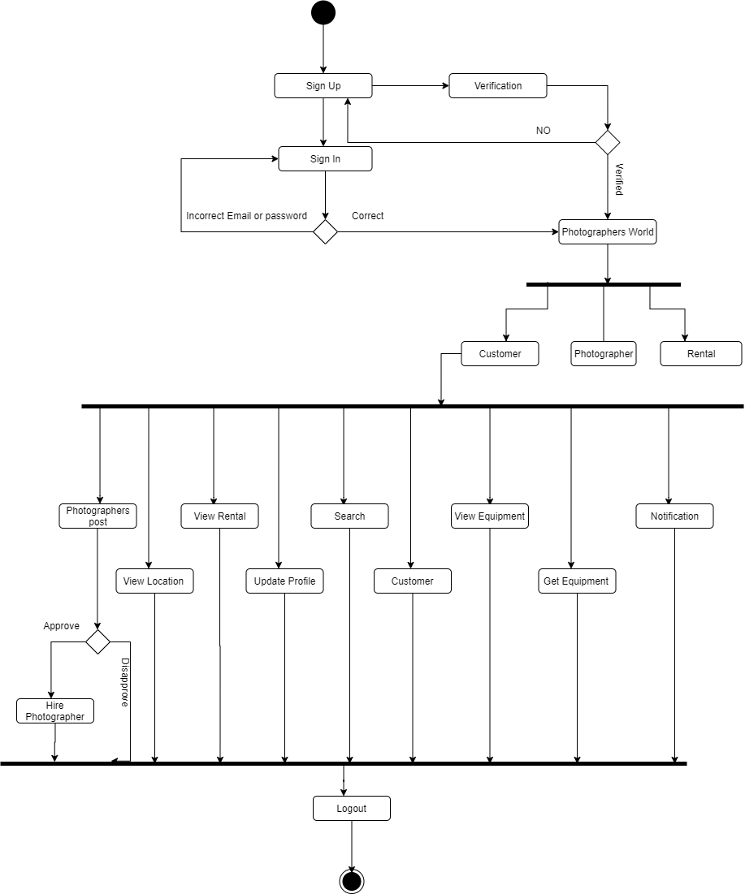
Figure 4.6 Customer Activity Diagram
Figure 4.6 shows there is an activity performed by Customer where he simply logs in to enter in the application and website can view photographer and rental He can view their location and hire them. He also can buy an item from the Rental. He also hires and sees the response of that person who hires him in a notification. The customer will add posts in Bidding Panel. He wants to hire photographer for an event on the basis of photographer work.

4.4.2 Rental Activity Diagram

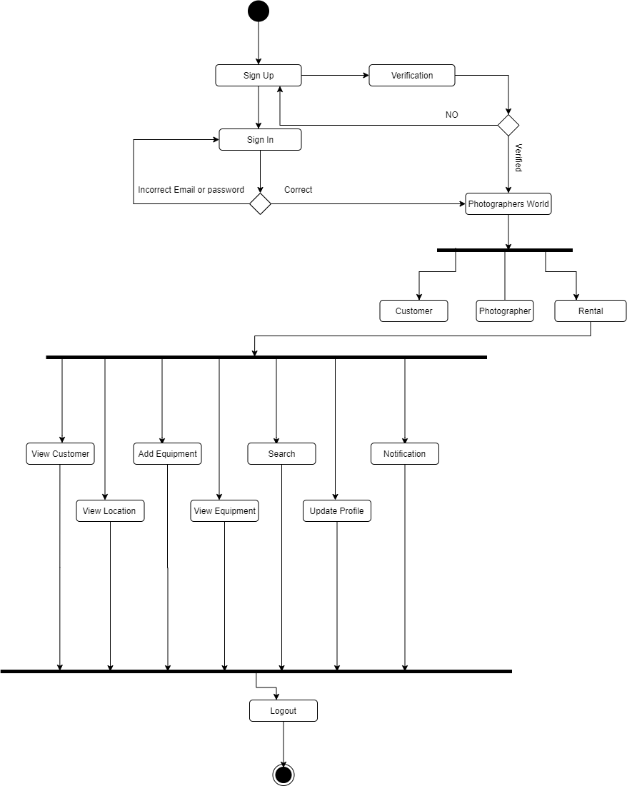
Figure 4.7 Rental Activity Diagram

Figure 4.7 shows there is an activity performed by Rental where he simply logs in to enter in the application and website and view equipment and gave equipment on rent to the users. Rental can update profile and add equipment and see the notification.

4.4.3 Admin Activity Diagram

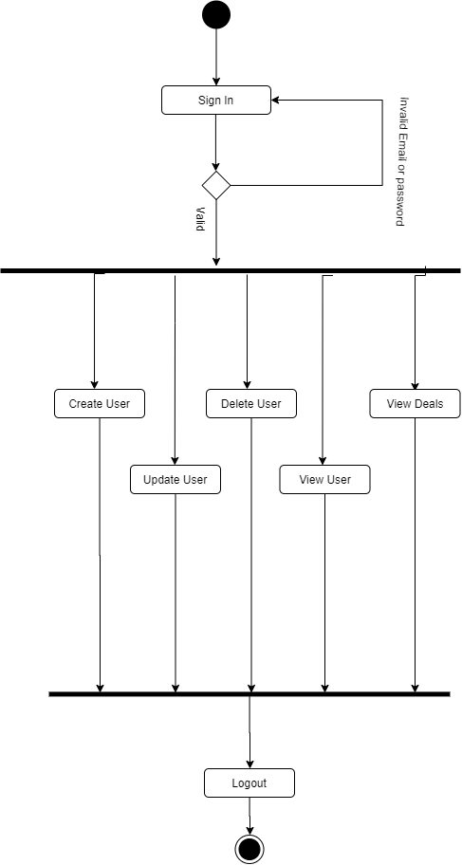

4.8 Admin Activity Diagram

Figure 4.8 shows there is an activity performed by the admin where he simply login to enter in the application and website and create user, update user, view user and delete user. And can see the deals between photographer, customer and rental.

4.4.4 Photographer Activity Diagram

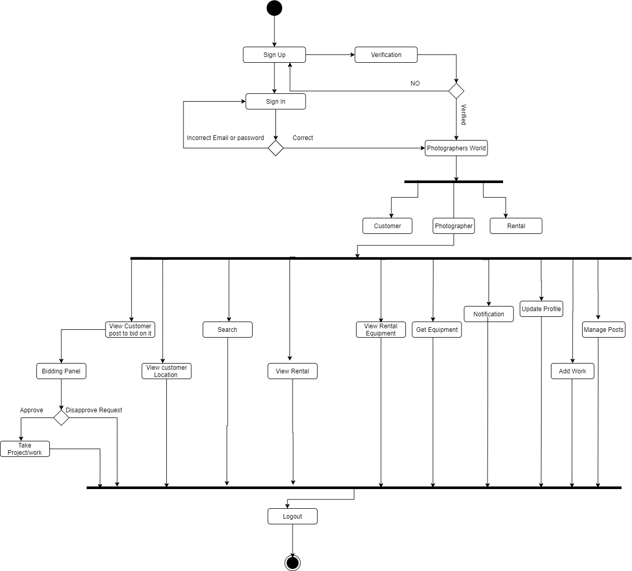
Figure 4.9 Photographer Activity Diagram

Figure 4.9 shows that there is an activity performed by the photographer where photographer simply login to enter in the application and website and can see the customer post where photographer bid on it. Through this activity customer will easily hire photographer. Photographer can add their work.

4.5 Sequence Diagram

Sequence diagrams used by model the interactions between objects in a single use case. They illustrate how the different parts of a system interact with each other to carry out a function, and the order in which the interactions occur when a particular use case is executed. In simpler words, a sequence diagram shows different parts of a system work in a ‘sequence’ to get something done.

4.5.1 Customer Sequence Diagram

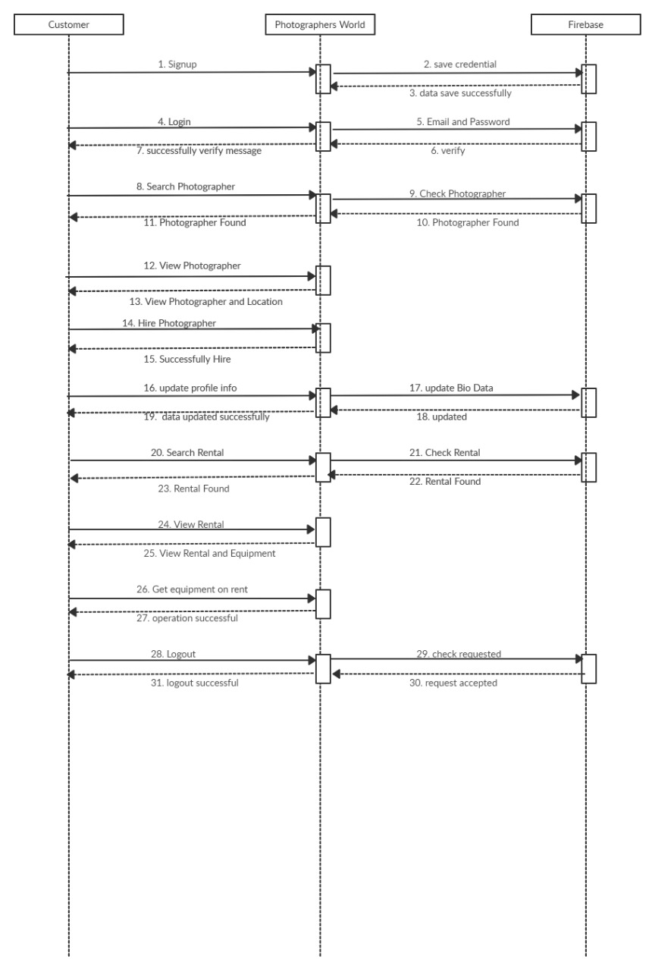

Figure 4.10 Customer Sequence Diagram

Figure 4.14 shows the Sequence diagram which represents the behavior of customers with the application and website. It shows a sequence of activities performed by Customer where he simply logs in to enter in Photographers World application and website can search photographer, view photographer, hire photographer, search rental and view rental. He can also see the equipment and get equipment on rent or buy on specific amount. And simply logout from one click.

4.5.2 Photographer Sequence Diagram

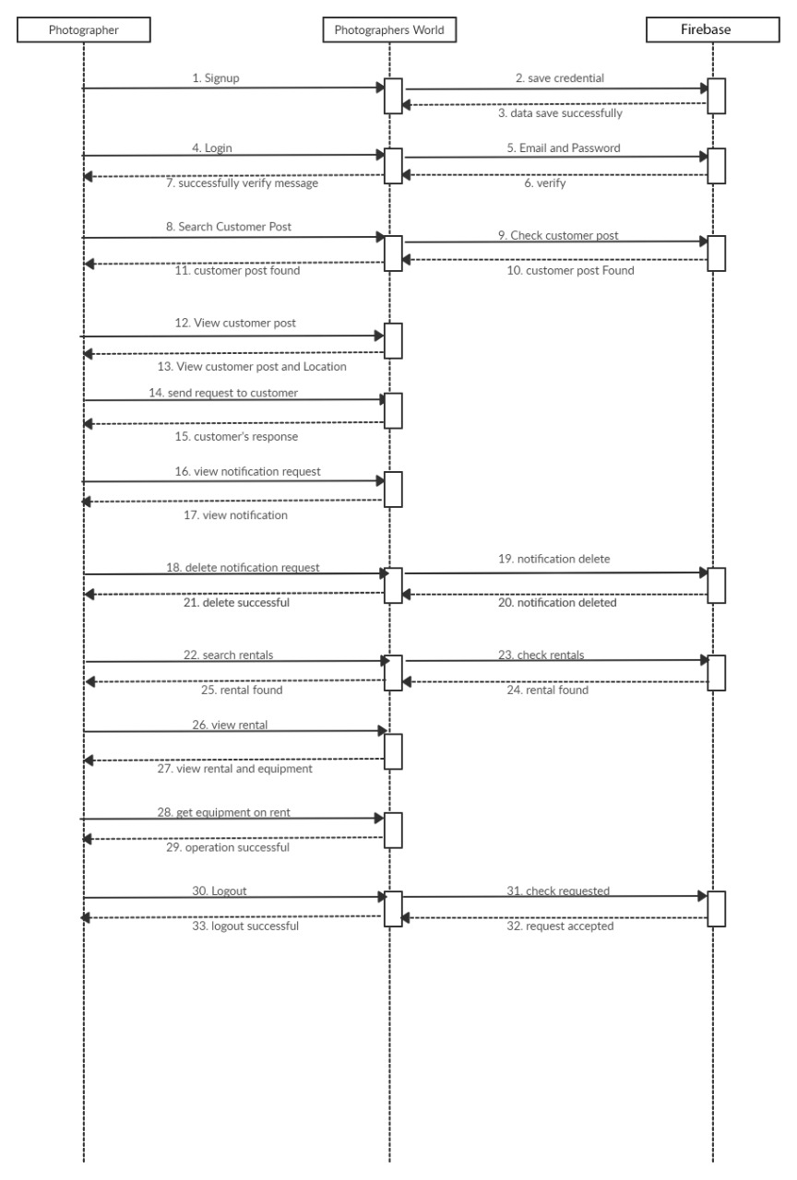
Figure 4.11 Photographer Sequence Diagram

Figure 4.11 shows the Sequence diagram which represents the behavior of photographer with the application and website. It shows a sequence of activities performed by photographer where he simply logs in to enter in photographers World application and website he can search customer post, send request to customer, view notification and delete notification. Photographers can search rentals, view rentals equipment and get equipment on rent. And simply logout from the application and website Photographer World.

4.5.3 Rental Sequence Diagram

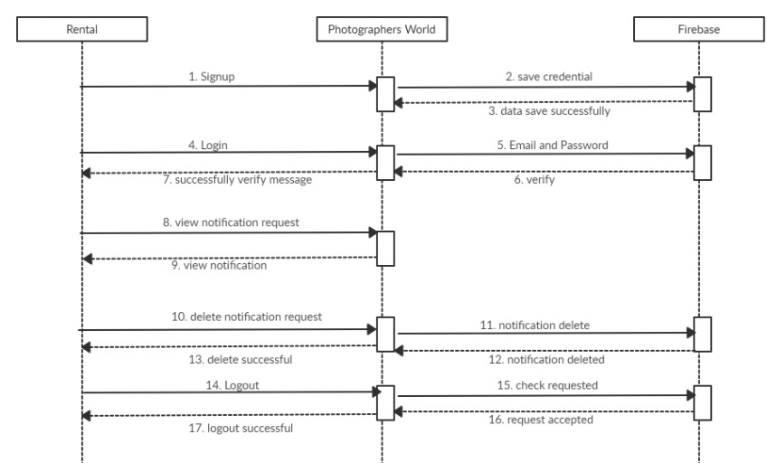

Figure 4.12 Rental Sequence Diagram

Figure 4.12 shows the Sequence diagram which represents the behavior of rental with the application and website. It shows a sequence of activities performed by rental where he simply logs in to enter in photographers World application and website and can see and delete the notification. And add own equipment and gave on rent or sell on specific price. Rental can easily logout from the application through one click.

4.5.3 Admin Sequence Diagram

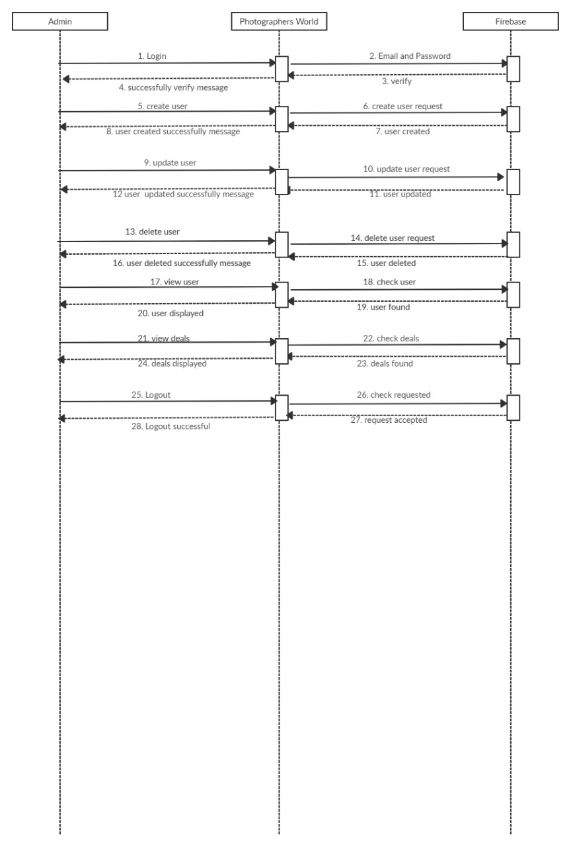
Figure 4.13 Admin Sequence Diagram

Figure 4.12 shows the Sequence diagram which represents the behavior of Admin with the application and website. It shows a sequence of activities performed by admin where he simply logs in to enter in photographers World application and website and can create the users, delete users. And also can view the user. Admin can see the deals between customer, photographer and rental. Admin can easily logout from application and website through one click.

4.6 Data Flow Diagram

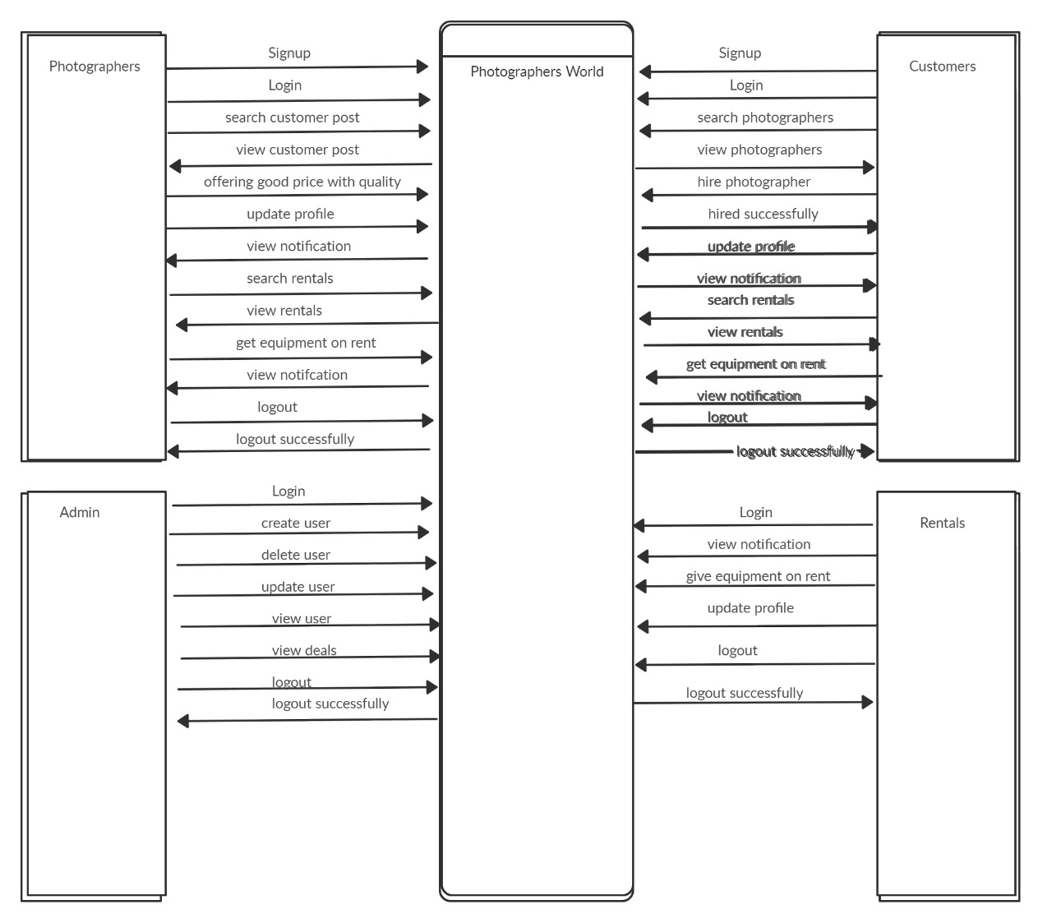

Figure 4.14 Data Flow Diagram

